“What would Seth Godin do?” plugin for Joomla!
User's Guide
Table of Contents
Introduction 1
Installation 1
Configuration 1
Plug-in Details 2
Plug-in parameters 2
License 3
Copyright Notice 3

Introduction
The purpose of this module is to implement Seth Godin's idea to treat new visitors differently than returning ones, based on a cookie, as appeared in his “...in the middle, Starting” blog post. It's a good idea, as it can increase the number of people who subscribe to your RSS feed, newsletter and generally help people come back to your site.
The idea is implemented in a rather simple manner: new visitors are presented with a message of your liking. The message is displayed on the top and bottom of your articles, in single article display view. After they have visited your site for a few times (you can set how much is that) the message disappears. The counting is done using cookies set on your visitors' browsers.
This plug-in can substitute our module by the same name. Unlike the module, it requires practically nothing more than configuration; the message is automatically added above and below the contents of your articles, without the need to publish a module or include any special processing instruction in your articles. This makes it ideal for blog-type sites, where articles are added all the time and as an author you don't want to give this feature a second thought; it just works.

Installation
You can install this just like any regular Joomla! plugin. Log in to your site's administrator section, click on the Extensions → Install / Uninstall menu item. Click on the Browse... button, select the module package (ZIP) file and click on the Upload File & Install button.

Configuration
The plugin configuration can be performed with the standard Joomla! manner, that is by using the Extensions → Plug-Ins menu and directly editing the “Content - What would Seth Godin do?” plugin entry (tip: it's of the Content type, should you need to filter the view in order to locate it easily). Do note that you must publish the plug-in in order to work at all.

Plug-in Details
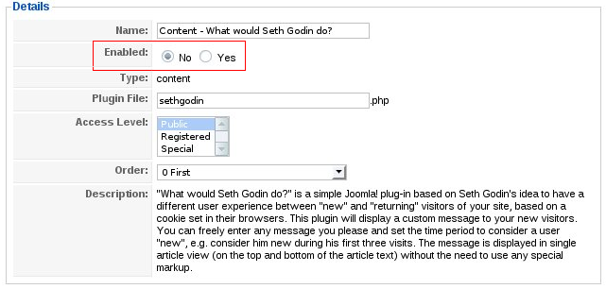Picture 1: Plug-in details
On the left hand side of the plug-in editor page, you will find the standard Joomla! “Details” section. It is very important to enable the plug-in, by setting the Enabled option to Yes. Otherwise, nothing will be shown to new visitors!

Plug-in parameters
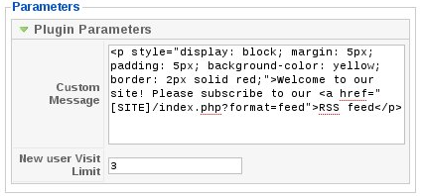Picture 2: Plug-in parameters
The parameters can be found on the right hind of the module editor, under the “Plugin Parameters” pane heading. They are:
- Custom message. This is the message you want to show to your new visitors. You can freely enter any HTML you'd like, even Javascript, embedded video etc. There is one macro, [SITE], which will be substituted by your site's URL before the message is displayed. You can understand how it is used by observing the sample message in the picture above.
- New user Visit Limit. This is after how many visits your visitors will stop seeing the message. The default value, 3, means that during the first three visits the message will be displayed, but on the fourth and later visits from the same browser the message will disappear.
A note on visit limit counting: Multiple visits performed in the same calendar date (according to your site's server clock) and within the same session do not count towards this limit. For example, if someone visits your site 5 times in, let's say Monday, 2 times in Wednesday and 4 times in Thursday, he will only be counted as having performed 3 visits, not 11 visits. This is on the grounds that most people might find you from a search engine, visit your site, accidentally wander off your page and re-visit using the search engine's link. As they haven't really had the chance to familiarize themselves with your site, counting this behavior as two visits would make your message disappear too soon to be effective.
Also note that the cookie set on your visitors' browsers is set to expire in three months. This means that if someone hasn't visited your site for at least three months (90 days), he will be considered a new user and shown the message.

License

This module is distributed under the terms of the GNU General Public License, version 3 of the license or – at your option – any later version. The full text of the license is available on-line at http://www.gnu.org/licenses/gpl.html.

Copyright Notice
“What would Seth Godin do?” plug-in for Joomla!, version 1.0
Copyright © 2009 Nicholas K. Dionysopoulos / cmsmoz.com
This program is free software: you can redistribute it and/or modify it under the terms of the GNU General Public License as published by the Free Software Foundation, either version 3 of the License, or (at your option) any later version.
This program is distributed in the hope that it will be useful, but WITHOUT ANY WARRANTY; without even the implied warranty of MERCHANTABILITY or FITNESS FOR A PARTICULAR PURPOSE. See the GNU General Public License for more details.
You should have received a copy of the GNU General Public License along with this program. If not, see http://www.gnu.org/licenses/.

Strictly speaking, Joomla! starts a session upon visiting the site for the first time. The expiration time of the session is set in the Global Configuration. If the session expires between subsequent visits within the same day, these visits will count towards the New user Visit Limit.

